

Connected Vehicle Electronics

**Concept of Operations**

**(ConOps)**

**Integrated Dash Camera**

**Version 0.06**

**05/21/2021**

Printed Copies are UNcontrolled

***FORD MOTOR COMPANY***

***CONFIDENTIAL***

**The information contained in this document is Proprietary to Ford Motor Company. Disclosure or distribution to unauthorized persons is strictly prohibited.**

**Copyright, Ó 2016 Ford Motor Company**

**Confidential and Proprietary – Ford Motor Company**

This document contains information developed and accumulated by and for FORD MOTOR COMPANY. As such, it is a proprietary document, which, if disseminated to unauthorized persons, would provide others with restricted information, data, or procedures not otherwise available, exposing the FORD MOTOR COMPANY to potential harm.

Employees and suppliers having custody of this specification or authorized to use it must be cognizant of its proprietary nature and ensure that the information herein is not made available to unauthorized persons.

FORD MOTOR COMPANY reserves the right to protect this work as an unpublished copyrighted work in the event of an inadvertent or deliberate unauthorized publication. FORD MOTOR COMPANY also reserves its rights under copyright laws to protect this work as a published work.

This document or portions thereof shall not be distributed outside FORD MOTOR COMPANY without prior written consent. Refer all questions concerning disclosure to the author(s) or to the Forward Model Radio Section, Ford Motor Company.

# 

Contents

1 Introduction 6

1.1 Audience 6

1.2 Feature Vision 6

2 Feature Analysis 7

2.1 Motivation 7

2.2 Background Study 7

2.3 Minimum Viable Product 7

2.4 System (and customer) Use Cases 7

2.4.1 Video Loop Recording 7

2.4.2 User Sets Read-Only While Recording 8

2.4.3 Auto-Set Read-Only While Recording 8

2.4.4 Video Playback 8

2.4.5 Set/Clear Read-Only During Playback 9

2.4.6 Delete Video 9

2.4.7 Store Default Config 9

2.4.8 One-Touch Trigger Recording 10

2.4.9 Display Storage Status 10

2.5 Failure Mode Scenarios 10

3 Solution Evaluation 11

3.1 Solution Options 11

3.2 Solution Recommendation 11

3.3 Assumptions 11

3.4 Constraints 11

3.5 Dependencies 11

3.6 Scope 11

3.6.1 In Scope: 11

3.6.2 Out of Scope: 11

4 Design Analysis of the Proposed Solution 12

4.1 Functional System Architecture 12

4.1.1 Ford Pass Functions list: 12

4.1.2 Ford Cloud/SDN 12

4.1.3 TCU Functions 12

4.1.4 ECG Functions list 12

4.1.5 SYNC 13

4.1.5.1 HMI Wireframes 13

4.1.5.2 Procedures 15

4.2 Functional Interface Analysis 15

4.2.1 Ford pass <-> SDN 15

4.2.2 TCU <-> ECG 15

4.2.3 SYNC <-> ECG 15

4.2.4 ECG <-> Ford Cloud 15

4.3 Data Usage Requirements 15

4.4 Message Sequence Diagram 16

4.4.1 Recording 16

4.4.2 Playback 17

4.5 System Functional Requirements 18

4.5.1 General system requirements 18

4.5.2 FordPass 18

4.5.3 Ford Cloud 18

4.5.4 TCU 18

4.5.5 ECG 18

4.5.6 SYNC 18

4.6 Impact Analysis Summary on FNV2.0 IVIC Modules 19

5 Glossary 20

6 References 21

7 Document Approval 22

Revision History

|  |  |  |  |  |
| --- | --- | --- | --- | --- |
| **Revision** | **Author** | **Description** | **Sections Affected** | **Release Date** |
| 0.01 | A. Shokry | Document created | All | 11-Aug-2020 |
| 0.02 | C. Neubeck | Document review | Up to section 3 | 11-Aug-2020 |
| 0.03 | A. Shokry | Functional Analysis | 4 | 11-Aug-2020 |
| 0.04 | A. Shokry | Ethernet load, one-touch record | 2, 4 | 21-Sep-2020 |
| 0.05 | M. Eteer | Renamed to Integrated Dash Cam and removed ADAS/DAT portion of feature | All | 14-May-2021 |
| 0.06 | M. Eteer | Added Functional Requirements and Interface Sections | 4.7, 4.8 | 29-May-2021 |

# 

# Introduction

The objective of the concept of operation (ConOps) document is to perform an initial technical analysis of the new vehicle features, evaluate solution options and provide design and solution recommendation. The technical analysis includes functional level software and interface impact analysis.

The technical analysis performed during this phase would enable the development teams to estimate the design and implementation efforts. The information can also be leveraged for developing detailed feature specifications

The focus of the technical analysis in this document is the Integrated Dash Camera feature, also known as IDC and Integrated Dashcam. The distinction of Enhanced Dashcam vs Integrated Dashcam comes from the ADAS/DAT portion of the feature; the inclusion of ADAS/DAT makes Enhanced, the lack of ADAS/DAT makes Integrated.

Audience

Below are departments identified as the stakeholders of this feature, and can be consulted for input during the Pre-PS feature analysis

* CVP&P Feature Owner
* EESE Feature Owner
* FNV2.0/3.0 Platform Development
* Infotainment SPSS author
* R&A EESE <AR> Pre Feature Owner

Feature Vision

The Integrated Dash Camera system allows users to capture vehicle data and video from a vehicle imaging surrounding system while driving and store the recorded data on removable on-board storage, namely a USB. The camera system will consist of one interior camera mounted behind the vehicle windshield glass without the obstruction from interior components (RVMD, Shade lines, brackets and other small trim pieces). Based on user command, the camera captures video of the exterior environment of the car at all times while driving as long as the portable available memory allows room to store files. The recorded files are available for the user to playback on the centerstack display once the vehicle is in “Park” position. Drivers are able to configure the recording experience via the centerstack HMI (Feature enable/disable and recording settings). In addition, the Integrated Dash Camera system allows users to select the vehicle metadata to be recorded alongside the video files. The metadata options (toggleable via settings) include GPS, vehicle speed, and pedal position. The Date/Time and VIN metadata items are always recorded with the video files for traceability purpose.

# Feature Analysis

Motivation

Provide Ford vehicle owners with the option to record their driving experience, alongside some metadata, for scenic or any other purposes. This would also be a built in option for a dash camera system therefore removing a customers need to pursue aftermarket solutions or risk having their aftermarket camera system stolen in event of a break in.

Background Study

Minimum Viable Product

The base requirements for IDC to be enabled is:

* The dash cam point of view camera and the AR ECU.
* Data enabled USB connected to Phoenix.
* HMI screen 8, 12 or 15 inch size.
* Phoenix
* ECG 2.0

System (and customer) Use Cases

### Video Loop Recording

|  |  |
| --- | --- |
| **Actors** | ECG, ADAS/AR, SYNC, AR ECU |
| **Pre-conditions** | * The Dash Camera, 360˚ view cameras and high-end ADAS are present. * SYNC 4.0 with HMI is present. * A USB drive plugged in the SYNC port. * Vehicle is in Ignition-ON and SYNC menu is unlocked for selection (vehicle speed below threshold). |
| **Scenario Description** | * User selects the desired camera. * User selects the target USB drive. * User chooses whether to record 1, 3 or 5 minute segments. * User selects the desired vehicle data to be recorded, such as:   + Speed.   + GPS location.   + Steering angle.   + Outside temperature.   + Gas and brake pedals.   + Engine RPM.   + G-force. * User selects the video quality; resolution. * User press “Allow recording” button and triggers recording. * The vehicle continuously records video segments of the specified time for the parallel streams, until the user terminates recording. * The HMI shall display a recording indicator icon. * If the USB drive runs out of space before the user terminates recording, automatically delete the oldest files that are not marked as read-only. |
| **Post-conditions** | * The desired streams are recorded on the selected USB drive. Each video stream and vehicle data is in a separate file and has to be synchronized by date/time stamp. |
| **Interfaces** | ADAS 🡨🡪 ECG, ECG 🡨🡪 SYNC🡨🡪AR ECU |

### User Sets Read-Only While Recording

|  |  |
| --- | --- |
| **Actors** | ECG, ADAS/AR, SYNC, AR ECU |
| **Pre-conditions** | * The Dash Camera, 360˚ view cameras and high-end ADAS are present. * SYNC 4.0 with HMI is present. * A USB drive plugged in the SYNC port. * Vehicle is in Ignition-ON and SYNC menu is unlocked for selection (vehicle speed below threshold). |
| **Scenario Description** | * User drives through an important event or experienced an incidence. * User taps the icon on the HMI to protect the current video segments being recorded. * All the parallel video segments are marked read-only, so that they are not auto-deleted when recording loops. |
| **Post-conditions** | * The video files marked read-only are kept on the USB drive and are not auto-deleted by EDC. |
| **Interfaces** | ADAS 🡨🡪 ECG, ECG 🡨🡪 SYNC 🡨🡪AR ECU |

### Auto-Set Read-Only While Recording

|  |  |
| --- | --- |
| **Actors** | ECG, ADAS/AR, SYNC, AR ECU |
| **Pre-conditions** | * The Dash Camera, 360˚ view cameras and high-end ADAS are present. * SYNC 4.0 with HMI is present. * A USB drive plugged in the SYNC port. * Vehicle is in Ignition-ON. |
| **Scenario Description** | * EDC receives an indication of vehicle vibration that exceeds a certain threshold. * All the parallel video and vehicle data segments currently being recorded are marked read-only, so that they are not auto-deleted when recording loops. |
| **Post-conditions** | * The video and data files marked read-only are kept on the USB drive and are not auto-deleted by EDC. |
| **Interfaces** | ADAS 🡨🡪 ECG, ECG 🡨🡪 SYNC🡨🡪AR ECU |

### Video Playback

|  |  |
| --- | --- |
| **Actors** | ECG, SYNC |
| **Pre-conditions** | * SYNC 4.0 with HMI is present. * A USB drive plugged in the SYNC port. * Vehicle is in Ignition-ON and Parked. |
| **Scenario Description** | * User browses the video files recorded by EDC. * User selects one of the files to Playback. * The video is played on the screen overlaid with the vehicle data, such as the data and time of recording and VIN, besides the data selected by the user at recording time. * The user has soft-buttons to Delete file, Pause, Play, Fast-Forward and Rewind through the video at 2x the speed. |
| **Post-conditions** | Video playback on SYNC HMI screen will be fisheye and with good quality image. It supports 8, 12 and 15 inch display sizes |
| **Interfaces** | ECG 🡨🡪 SYNC |

### Set/Clear Read-Only During Playback

|  |  |
| --- | --- |
| **Actors** | ECG, SYNC |
| **Pre-conditions** | * SYNC 4.0 with HMI is present. * A USB drive plugged in the SYNC port. * Video files recorded by EDC are present. * Vehicle is in Ignition-ON and Parked. |
| **Scenario Description** | * User is playing-back a video in EDC. * User taps the icon on the HMI to protect/unprotect the current video. * The video is marked/unmarked read-only, according to the user choice. |
| **Post-conditions** | * The video file and correlated vehicle data file is marked/unmarked read-only. |
| **Interfaces** | ECG 🡨🡪 SYNC |

### Delete Video

|  |  |
| --- | --- |
| **Actors** | ECG, SYNC |
| **Pre-conditions** | * SYNC 4.0 with HMI is present. * A USB drive plugged in the SYNC port. * Video files recorded by EDC are present. * Vehicle is in Ignition-ON and Parked. |
| **Scenario Description** | * User browses the video files recorded by EDC. * User selects one of the files to Delete. * The video and correlated vehicle data file is removed from the USB drive even if it was read-only, and its space is released. |
| **Post-conditions** | * The selected video and related vehicle data file is deleted. |
| **Interfaces** | ECG 🡨🡪 SYNC |

### Store Default Config

|  |  |
| --- | --- |
| **Actors** | ECG, ADAS/AR, SYNC |
| **Pre-conditions** | * The Dash Camera, 360˚ view cameras and high-end ADAS are present. * SYNC 4.0 with HMI is present. * Vehicle is in Ignition-ON. |
| **Scenario Description** | * User selects the desired cameras. * User selects the target USB drive. * User chooses whether to record 1, 3 or 5 minute segments. * User selects the desired vehicle data to be recorded. * User selects the vibration settings. * User selects the video quality; resolution. * User chooses to record the supplied configs as the EDC default. * User presses the allow to record button. |
| **Post-conditions** | * The next times user chooses EDC recording to start automatically, it will use the default configs stored as well as allow record command. |
| **Interfaces** | ADAS 🡨🡪 ECG, ECG 🡨🡪 SYNC |

### One-Touch Trigger Recording

|  |  |
| --- | --- |
| **Actors** | ECG, ADAS/AR, SYNC |
| **Pre-conditions** | * The Dash Camera, 360˚ view cameras and high-end ADAS are present. * SYNC 4.0 with HMI is present. * Vehicle is in Ignition-ON. * EDC Default Config are present. |
| **Scenario Description** | * User has a soft button on the HMI screen to trigger recording. * When user touches the button, EDC will use the stored configs to start recording immediately without further dialog with the user. |
| **Post-conditions** | None |
| **Interfaces** | ADAS 🡨🡪 ECG, ECG 🡨🡪 SYNC |

### Display Storage Status

|  |  |
| --- | --- |
| **Actors** | ECG, SYNC |
| **Pre-conditions** | * SYNC 4.0 with HMI is present. * A USB drive plugged in the SYNC port. Vehicle is in Ignition-ON and Parked. |
| **Scenario Description** | * User selects a USB drive plugged to the vehicle. * User chooses to view the storage status of the selected drive. * The storage status is displayed as follows:   + Total space: size of the USB drive.   + Free space: total free space on the USB drive.   + Archived size: total size of the files with read-only attribute under the directory of the requesting feature.   + Temporary size: total size of the files without read-only attribute under the directory of the requesting feature. |
| **Post-conditions** | None |
| **Interfaces** | ECG 🡨🡪 SYNC |

Failure Mode Scenarios

* Can not read/write from/to USB
* Camera unavailable
* VRP responds negatively to request
* Recording ended without request from IDC
* Recording failed to start
* Current recording file failed to change protect status
* Recorded file failed failed to change protect status
* Recorded file failed to delete
* Recorded file failed to play
* Playback commands failed
* FRCC signal missing
* Metadata failed to save
* Metadata failed to retrieve from VIM

# Solution Evaluation

Solution Options

Solution Recommendation

* Develop an application on Phoenix that implements the IDC functionality.
* IDC uses the Video Recording & Playback (VRP) function on Phoenix to do the actual writing/reading of video streams to/from files, respectively as well as vehicle data.
* The IDC interface to/from VRP is SOA messages through ECG.
* IDC listens to the Ford Real-time Collision Classification (FRCC) CAN message and reads its severity level, so that it can automatically protect files as read-only if the threshold severity level is met.
* For video playback, IDC will locally establish an RTP server to which VRP will stream the selected video. IDC will display that stream on the HMI.
* IDC can directly use the services offered by VRP to;
  + Pause, Play, FF (if possible) and RW (if possible) in 2x speed during playback.
  + Obtain and display USB storage statistics.
  + Delete files.
  + Mark/unmark files as read-only.
  + Time stamp video and data files to allow synchronization during playback.

Assumptions

(None)

Constraints

(None)

Dependencies

* Requires ECG/VIM support of vehicle data messages
* FRCC Signal from ECG indicating the collision severity level.
* Requires VRP to provide data/time stamp on video and data files for synchronization
* Requires VRP to set up recording with camera manager on ECG
* Requires VRP to playback videos
* Requires camera manager on ECG
* Requires camera service implemented on ECUs providing camera input
* FNOL feature is present

Scope

### In Scope:

* Recording of video and metadata streams in loop mode for unlimited time during ignition run/start.
* Playback of a single video synchronized with video data at the time on the centerstack.
* Automatically starting recording using the config stored at each ignition run/start if enabled.

### Out of Scope:

* Recording in ignition-off.
* Video editing and rendering.
* Camera streams that are not sent over Ethernet from ECG to Phoenix.
* Advanced File Management features, such as copy, move, rename, etc.
* Recording more than 1 video stream.
* Playback of multiple videos at the same time.

# Design Analysis of the Proposed Solution

Functional System Architecture



### Ford Pass Functions list:

None

### Ford Cloud/SDN

None

### TCU Functions

None

### ECG Functions list

Reuse:

* SOA Broker to forward commands and responses between IDC and VRP.

### Phoenix Functions list

* Store default settings and the user selected settings
* Request camera recording to begin and end alongside vehicle data
* Request playback to begin with selected file
* Request playback actions such as pause, stop, resume
* Display menu for user interaction and take user input
* Monitor FRCC signal
* Request recording to be read-only
* Request recorded file to be deleted
* Request recorded file to toggle read-only status
* VRP-Start Recording
* VRP-Stop Recording
* VRP-List Recordings
* VRP-Protect Recording
* VRP-Delete Recording
* VRP-MemoryConsumptionStat
* VRP-Start Playback
* VRP-Pause Playback
* VRP-Stop Playback
* VRP-Resume Playback
* VRP-JumpVideoToTimeFrame

#### HMI Wireframes

Following are sample wireframes. The full list is provided in [2].

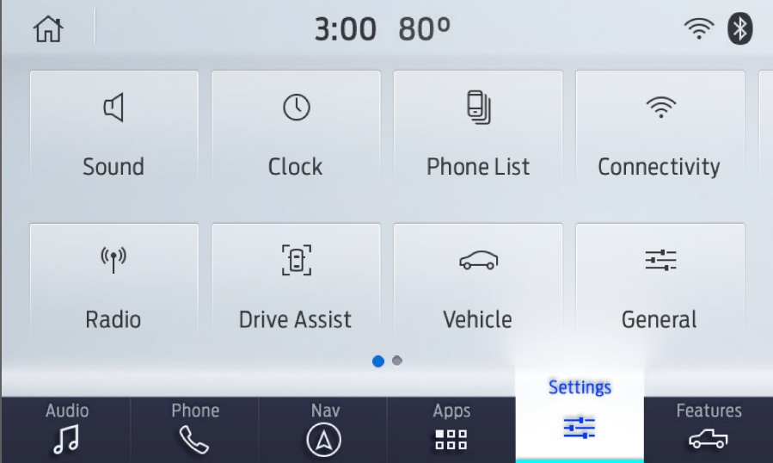

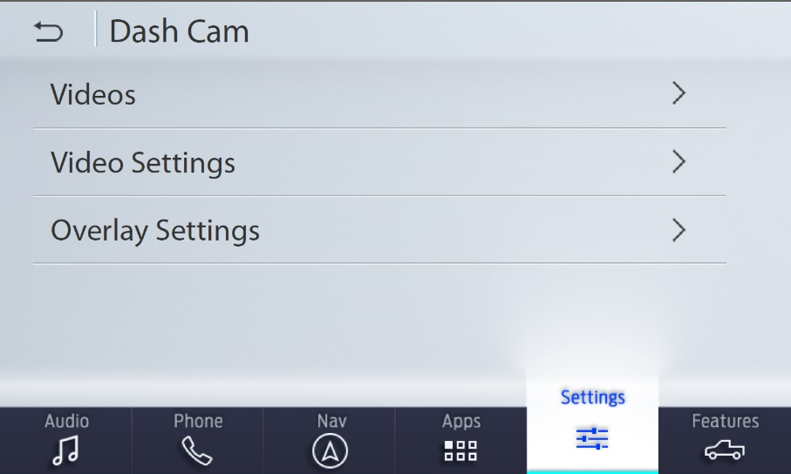

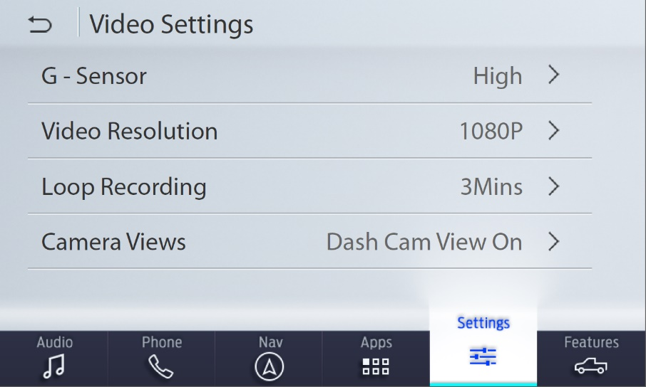

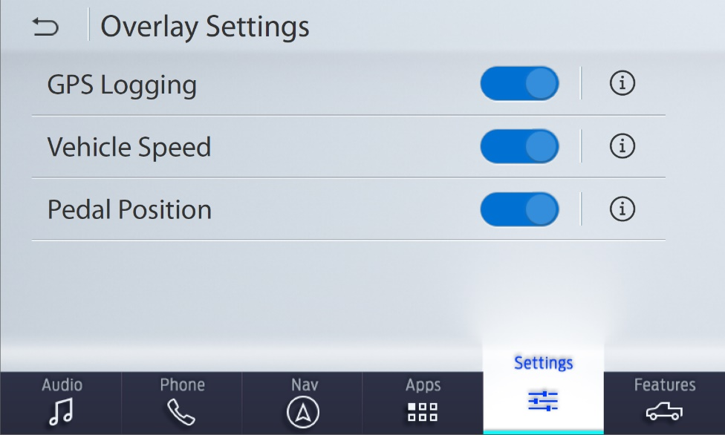

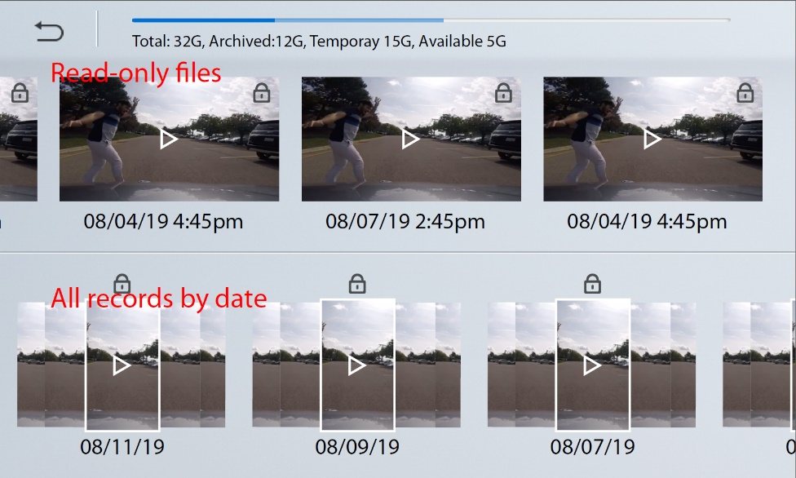

#### Procedures

Following are the procedures from a high-level for the key events. They are detailed in the FS document.

|  |  |  |
| --- | --- | --- |
| Conditions | Trigger | Procedure |
| Idle | Start Recording | * Forward the user inputs (or the stored config) and the request to VRP. * Request VRP to publish the recording status regularly. * Display the status on the screen. |
| Idle | Save settings | * Store the default settings to be used next time for auto-recording |
| Default settings and auto-recording consent are present | Ignition turned on | * Automatically forward the default settings together with w recording request to VRP * Indicate the auto-recording by the persistent icon. |
| Recording | FRCC with severity level above threshold | * Automatically request VRP to mark all the actively being recorded files as read-only. |
| Idle | Start Playback | * Establish a local RTSP server, on which IDC will receive the playback stream. * Send the playback request to VRP. * Display the received stream on HMI. |
| *Any* | Request storage status | * Request the storage status of the selected USB drive from VRP. * Display the status summary to the user. |
| ~~Playback~~ | ~~FF/RW request~~ | * ~~Forward the FF/RW request to VRP.~~ * ~~VRP will send the playback stream already in double the speed and the requested direction.~~ * ~~EDC displays the received stream as-is on the screen.~~ |

Most other procedures are handled by VRP as-is

## Functional Interface Analysis

### Ford pass <-> SDN

None

### TCU <-> ECG

None

### Phoenix <-> ECG

Reuse:

* The VRP API messages to provide the IDC required services, routed over SOA [1].
* ECG sending FRCC signal over CAN
* ECG providing CAN data via VIM

### ECG <-> Ford Cloud

None

Data Usage Requirements

None

Message Sequence Diagram

### Recording



### Playback



System Functional Requirements

### General system requirements

* AR with Dashcam.
* Ethernet bandwidth: while Ethernet load changes with the user-selected video resolution, the maximum Ethernet bandwidth required is 50 Mbps, as the bitrate of the highest resolution is 10 Mbps per stream.

### FordPass

None

### Ford Cloud

None

### TCU

None

### ECG

* Camera Manager to manage the video streams from AR to Phoenix.

### Phoenix

* Processing power to handle one video stream.
* USB transfer speed to write video stream.

## Impact Analysis Summary on FNV2.0 IVIC Modules

|  |  |
| --- | --- |
| **Module** | **Impact Size** |
| TCU | (None) |
| ECG | XS |
| Phoenix | M |

## Functional Requirements

### Recording Functions

#### Integrated Dash Cam shall leverage the Video Recorder and Playback (VRP) software component on Phoenix to record video and metadata and to playback videos with metadata

#### Integrated Dash Cam shall have an HMI option to enable/disable the feature

#### Integrated Dash Cam shall only be capable of recording during IGN ON

#### Integrated Dash Cam shall start recording when the feature status is set to Active during IGN ON

#### Integrated Dash Cam shall request for metadata to be recorded alongside the video

#### Integrated Dash Cam shall always record VIN and Date/Time as metadata

#### Integrated Dash Cam shall allow as an option to record Vehicle Speed, GPS, and Pedal Position as metadata

#### Integrated Dash Cam shall always request metadata to be encrypted regardless of the status of the optional metadata settings

#### Integrated Dash Cam shall only request to store files to USB drives

#### Integrated Dash Cam shall request recording in loop mode

#### Integrated Dash Cam shall have settings for video resolution and segment length

#### Integrated Dash Cam shall have the option of selecting 1, 3, and 5 minute segment lengths

#### Integrated Dash Cam shall, upon a change of settings, start a new recording session with the new settings

### Playback Functions

#### Integrated Dash Cam shall be capable of requesting videos to be played back and displayed on the HMI

#### Integrated Dash Cam shall have controls during video playback including: Pause, Resume, Protect/Unprotect, Delete, Return to Menu, and a video progress bar that can be used to jump forward and backward

#### Integrated Dash Cam shall only be capable of video playback when vehicle transmission is PARK

#### Integrated Dash Cam shall request video recordings to be named in the following format: Date Time Dashcam. For example “05212021 093215AM Dashcam”

#### Integrated Dash Cam shall replay the corresponding metadata file alongside the video file during playback

### General Feature Functions

#### Integrated Dash Cam shall be capable of storing settings

#### Integrated Dash Cam shall use the FNOL FRCC Severity CAN signal as a trigger to protect files

#### Integrated Dash Cam shall be capable of requesting and displaying the list of stored video files

#### Integrated Dash Cam shall be capable of protecting and deleting only videos that were recorded by Integrated Dash Cam

#### Integrated Dash Cam shall allow enabling/disabling of the optional metadata in the Integrated Dash Cam settings

#### Integrated Dash Cam shall request of the user to Accept recording via an HMI popup after feature status is set to active in the settings for the first time. If popup is Denied, feature status will change to Disabled and popup will appear again on next instance of setting feature status to Enabled. If popup is Accepted, popup will not appear again for subsequent enabling/disabling of feature status.

#### Integrated Dash Cam shall be capable of displaying the memory status of the USB

## Interfaces

### CAN/VIM

#### Ignition is used to determine whether or not the feature should be active

#### Transmission status is used to determine if playback is possible

#### FNOL FRCC Severity is used to determine if the current recording should be marked as protected

### Phoenix

#### VRP will be used to start/stop/manage video and metadata recording

#### VRP will be used to receive video and metadata streams for playback

#### VRP will be used manage the video library including retrieving a list of stored videos, protect/unprotect, and deleting videos

### ECG

#### SOA service will be used to route messages back and forth between Integrated Dash Cam and VRP

# Glossary

|  |  |
| --- | --- |
| **Acronym** | **Definition** |
| **AR** | Augmented Reality module |
| **EDC** | Enhanced Dashcam feature |
| **VRP** | Video Recording & Playback function |
| **IDC** | Integrated Dash Camera |
| **FRCC** | Ford Real-time Collision Classification |
| **ECG** | Enhanced Central Gateway |
| **TCU** | Telematics Control Unit |
|  |  |
|  |  |
|  |  |
|  |  |
|  |  |
|  |  |
|  |  |
|  |  |
|  |  |

# References

1. ConOps_VRP
2. V4.1_Wireframe191203
3. EDC DFMEA
4. FNOL FRCC
5. VideoRecorderService
6. VideoPlaybackService

# Document Approval

|  |  |  |  |  |
| --- | --- | --- | --- | --- |
| **Name** | **Department** | **Role** | **Email Confirmation** | **Date** |
|  |  |  |  |  |